

**Software Engineering Department**

**Capstone Project Phase A – 61998**

**PowerTrack - Smart Management Application for Orders and Inventory**

**Project code:**

**24-2-R-18**

**Supervisor:**

**Dr. Samah Idrees-Ghazawi**

**Students:**

**Reema Nasr**

[Reema.Nasr@e.braude.ac.il](mailto:Reema.Nasr@e.braude.ac.il)

**Amr Kalany**

[Amr.Kalany@e.braude.ac.il](mailto:Amr.Kalany@e.braude.ac.il)

**GitHub link:**

[amrkal/PowerTrack: Braude Final Project (github.com)](https://github.com/amrkal/PowerTrack)

# Abstract

Embarking on a groundbreaking journey in software development, this project aims to craft an innovative application tailored for an electrical company, transforming the landscape of order management and inventory tracking. By designing an intuitive interface, engineering robust backend functionalities, and integrating a seamless database, we aspire to revolutionize the management of products, orders, and stock levels. This avant-garde solution is set to enhance operational efficiency and redefine the management processes within the company.

Through meticulous planning and execution, we aim to deliver a tool that optimizes resource allocation, reduces operational costs, and significantly improves customer satisfaction, setting a new standard for industry practices. The application will incorporate advanced features such as real-time inventory updates, automated order processing, and comprehensive reporting tools to provide insights into inventory trends and operational performance.

Designed with scalability in mind, the user-friendly interface will allow the system to adapt to future growth and changing business needs. Robust security measures will be implemented to safeguard sensitive data, ensuring that the company’s information remains protected. By leveraging the latest technologies and best practices in software development, PowerTrack will provide a robust, efficient, and future-proof solution to the challenges of order management and inventory tracking in the electrical industry.

Table of Contents

**1. Introduction 4**

**2. Literature Survey 5**

**2.1 Literature Review 5**

**3. Expected Achievements 7**

**3.1 Outcomes 7**

**3.2 Unique Features 7**

**3.3 Criteria for Success 8**

**4. System Overview 9**

**4.1 Description of the Factory and Store Setup 9**

**4.2 Existing Systems (Server and Database) 10**

**5. Engineering Process 10**

**5.1 Requirements 10**

**5.1.1 Functional Requirements 11**

**5.1.2. Non-Functional Requirements 12**

**5.2. Determining the Technologies to Use 12**

**5.3. Challenges 12**

**6. Product 13**

**6.1 Software Architecture Diagram 13**

**6.2 Use Case Diagram 14**

**6.3 Activity Diagram 16**

**6.4 User Interface 16**

**7. Verification and Evaluation 29**

**8. References 34**

# **Introduction**

The electrical company faces significant challenges in efficiently managing orders, tracking inventory, and organizing stock. Reliance on manual processes or outdated systems often results in errors, delays, and inefficiencies, which adversely impact overall productivity and customer satisfaction. These inefficiencies can lead to inaccurate stock counts, missed order deadlines, and non-optimal resource allocation, all of which hinder the company's ability to meet customer demands and maintain a competitive edge in the market.

Currently, many electrical companies utilize a combination of spreadsheets, paper records, and legacy software systems to manage their inventory and orders. These existing solutions are often fragmented and lack real-time synchronization, leading to data discrepancies and operational bottlenecks. Additionally, these systems may not be scalable, secure, or capable of integrating with modern technologies, further exacerbating inefficiencies as the company grows.

To address these issues, PowerTrack Smart Management for Orders and Inventory proposes a comprehensive, automated solution tailored specifically for the needs of the electrical industry. This project aims to develop a custom application that will revolutionize the company's approach to order management and inventory tracking.

**Primary Objectives:**

1. **Design an Intuitive Interface:** Create a user-friendly interface that simplifies the management of products, orders, and stock levels, making it accessible for all employees, regardless of their technical expertise.
2. **Engineer Robust Backend Functionalities:** Develop a powerful backend system that ensures reliable performance, supports complex business logic, and facilitates seamless data processing.
3. **Integrate a Seamless Database System:** Implement a comprehensive database that provides real-time updates, maintains data integrity, and supports advanced reporting and analytics.

PowerTrack will incorporate advanced features such as automated order processing, real-time inventory updates, and detailed reporting tools to provide valuable insights into inventory trends and operational performance. These capabilities are designed to reduce manual effort, minimize errors, and improve overall efficiency. The solution will also be built with scalability and security in mind, allowing the system to adapt to future growth and changing business needs while safeguarding sensitive data.

By leveraging the latest technologies and best practices in software development, PowerTrack aims to deliver a robust, efficient, and future-proof solution that sets a new standard for order management and inventory tracking in the electrical industry. This project will ultimately enhance resource allocation, reduce operational costs, and improve customer satisfaction, positioning the company for sustained success in a competitive market.

# Literature Survey

A broad and detailed review of the tools and methods that exist today to solve the problem of efficient order management and inventory tracking reveals several existing tools and software solutions. Many companies use Enterprise Resource Planning (ERP) systems, specialized inventory management software, and automated order processing tools. These tools offer functionalities like real-time inventory updates, automated order workflows, and comprehensive reporting capabilities.

**Existing Tools:**

1. **Enterprise Resource Planning (ERP) Systems** [1]**:** ERP is usually referred to as a category of [business management software](https://en.wikipedia.org/wiki/Business_management_tools) (typically a suite of integrated [applications](https://en.wikipedia.org/wiki/Application_software)) that an organization can use to collect, store, manage and interpret data from many [business](https://en.wikipedia.org/wiki/Business_sector) activities
2. **Inventory Management Software** [2]**:** Tools like TradeGecko, NetSuite, and Fishbowl Inventory focus specifically on inventory tracking and management, offering features such as barcode scanning, real-time stock updates, and automated reordering.
3. **Automated Order Processing Systems** [3]**:** Software provide e-commerce platforms that automate order capture, processing, and fulfilment.

# Literature Review

A comprehensive review of existing literature underscores the critical need for efficient order management and inventory tracking in the electrical industry. Studies indicate that reliance on manual processes and outdated systems significantly contributes to operational inefficiencies, resulting in increased costs and decreased customer satisfaction. Research conducted by Smith and Jones (2020) [4] emphasizes the importance of automation in inventory management to ensure accuracy and timeliness in order processing.

Johnson et al. (2019) [5] further explore the advantages of integrated database systems, highlighting their role in delivering real-time updates and comprehensive reporting capabilities. These features are essential for informed decision-making and strategic planning. Their study demonstrates that companies implementing modern inventory management solutions see substantial improvements in operational efficiency and customer service levels.

Additionally, research by Brown and Green (2018) [6] focuses on the specific challenges faced by the electrical industry in managing inventory with outdated systems. They argue that generic ERP solutions often fail to meet the unique needs of this sector. The study concludes that industry-specific solutions tailored to the requirements of electrical companies can deliver significantly better results.

Existing solutions such as ERP systems and inventory management software offer a range of functionalities, but they often lack the customization required to meet specific industry needs. For example, generic ERP systems may not adequately address the unique requirements of the electrical industry, leading to a non-optimal performance. Furthermore, many current systems are not user-friendly, resulting in low adoption rates among employees and a continued dependence on manual processes.

PowerTrack aims to bridge this gap by providing a tailored solution designed to meet the specific needs of the electrical company. By integrating best practices from successful implementations in other industries and addressing the limitations of existing systems, PowerTrack will deliver a comprehensive, efficient, and user-friendly solution for order management and inventory tracking. This solution will incorporate real-time data updates, automation capabilities, and advanced analytics to enable better control over operations, optimize resource allocation, and enhance decision-making processes. Through its customized features and robust security measures, PowerTrack is poised to significantly improve profitability and customer satisfaction, ensuring sustained success in a competitive market.

PowerTrack’s development will be informed by a thorough analysis of industry requirements and an evaluation of the shortcomings of current tools. Research will continue to play a pivotal role in identifying the most effective strategies for integrating advanced technologies into the new system. The ongoing review of emerging trends and technologies will ensure that PowerTrack remains at the forefront of innovation, providing the electrical company with a robust, scalable, and future-proof solution for their order management and inventory tracking needs.

# 3. Expected Achievements

Our PowerTrack project is all about creating an application for managing orders and keeping track of inventory in the electrical industry.

# 3.1 Outcomes

The primary outcomes we expect to achieve with PowerTrack include:

1. **Enhanced Operational Efficiency:**

By automating order management and inventory tracking, we will significantly reduce manual effort, minimize errors, and streamline workflows. This will lead to increased productivity and lower operational costs. Previously, the company relied on a cumbersome process where electricians or store representatives would call in orders, which were then manually written down on paper by workers before being input into the computer. This process was time-consuming and prone to errors, causing delays and inefficiencies.

1. **Improved Customer Satisfaction:**

PowerTrack will process orders accurately and quickly. We'll always know what's in stock, so we can meet customer needs promptly. This means happier customers who'll stick with us for the long haul. The automated system will replace the old manual order entry process, reducing wait times and improving the overall customer experience.

1. **Scalability:**

Designed with scalability in mind, the system will be able to adapt to future growth and evolving business needs, ensuring sustained success in a competitive market.

1. **Data Security:**

PowerTrack will have strong measures in place to protect our sensitive information, keeping our company's data safe and sound.

# 3.2 Unique Features

1. **Real-Time Inventory Updates:**

The system will provide real-time updates on inventory levels, allowing for accurate tracking and management of stock. This feature will ensure that stock levels are always up to date, reducing the risk of overstocking or stockouts.

1. **Automated Order Processing:**

PowerTrack will automate the entire order processing workflow, from order capture to delivery preparation. This will enhance the accuracy and speed of order fulfillment, reducing the likelihood of errors and delays. It will replace the previous manual process of taking orders over the phone and entering them into the system by hand, which was both time-consuming and error prone.

1. **Comprehensive Reporting Tools:**

The system will include advanced reporting tools that provide detailed insights into inventory trends, order status, and overall operational performance. These reports will enable informed decision-making and strategic planning.

1. **User-Friendly Interface:**

A key focus of PowerTrack is to create an intuitive and user-friendly interface. This will ensure that employees at all levels of technical expertise can easily navigate and use the system, improving overall adoption and effectiveness.

1. **Scalability and Flexibility:**

The system will be designed to scale with the company’s growth and adapt to changing business needs. This flexibility will ensure that PowerTrack remains relevant and effective as the company evolves.

1. **Robust Security Measures:**

PowerTrack will implement advanced security protocols to protect against data breaches and unauthorized access. This will ensure that all sensitive data is safeguarded, maintaining the integrity and confidentiality of the company’s information.

# 3.3 Criteria for Success

1. **Accuracy:**

The system should accurately track inventory levels and process orders, minimizing errors and discrepancies.

1. **Efficiency:**

PowerTrack should significantly reduce the time and effort required for order management and inventory tracking, leading to increased productivity and lower operational costs. This includes eliminating the need for manual order entry from phone calls, thus reducing processing times and error rates.

1. **User Adoption:**

The system should be user-friendly and intuitive, ensuring high adoption rates among employees and minimizing the need for extensive training.

1. **Customer Satisfaction:**

The system should improve the speed and accuracy of order fulfilment, leading to enhanced customer satisfaction and loyalty.

1. **Scalability:**

PowerTrack should be able to scale with the company’s growth and adapt to evolving business needs, ensuring long-term relevance and effectiveness.

1. **Data Security:**

The system should implement robust security measures to protect sensitive data, ensuring the integrity and confidentiality of all information.

By achieving these outcomes and incorporating these unique features, PowerTrack aims to set a new standard for order management and inventory tracking in the electrical industry. The project’s success will be reflected in improved operational efficiency, optimized resource allocation, and enhanced customer satisfaction.

# 4. System Overview

We'll outline the structure of the factory and store, detailing their roles in production and distribution, as well as the current server and database systems that support their daily operations.

# 4.1 Description of the Factory and Store Setup

The factory specializes in the manufacturing of pipes and cables, primarily made of copper for electricians and other industrial applications. The factory includes several departments responsible for different stages of production, quality control, and packaging.

The store attached to the factory serves two main functions:

* **Distribution Point:**

The store serves as a distribution point where finished products are stored before being shipped to larger clients.

* **Retail Store:**

The store sells directly to individual electricians and other small businesses. It stocks a variety of electrical supplies, in addition to the pipes and cables manufactured by the factory.

The key components of the factory and store setup include:

* **Manufacturing Units:**

These units handle the production of pipes and cables, ensuring high-quality standards.

* **Quality Control:**

This department checks the products for any defects and ensures they meet industry standards.

* **Packaging:**

Finished products are packaged and labeled appropriately for storage and shipping.

* **Storage:**

The store maintains an inventory of finished products and other electrical supplies, tracking stock levels and ensuring that orders can be fulfilled promptly.

* **Retail Operations:**

The store manages sales to walk-in customers, handling orders for various electrical supplies in addition to the factory's products.

# 4.2 Existing Systems (Server and Database)

The company already has a server and database system in place to manage its core operations. The existing systems include:

* **Server:**

A centralized server that hosts the company’s internal applications and databases.

* **Database:**

A relational database system that stores data related to production, inventory, and sales. This database is used for recording manufacturing details, quality control results, current stock levels, and sales transactions.

However, the existing systems do not include functionalities for ordering, preparing products for delivery, or detailed storage counting. Orders are currently managed manually, and the process of preparing products for delivery involves significant manual effort. Sales to individual electricians and other customers are also handled manually, leading to inefficiencies and potential errors.

# 5. Engineering Process

To build an effective PowerTrack system, we begin by clearly defining and analyzing the necessary requirements, selecting appropriate technologies, and anticipating potential challenges. This approach ensures that the system meets both functional and non-functional needs while maintaining high performance, scalability, and security.

# 5.1 Requirements

The first step in the engineering process involves gathering and analyzing the requirements for the PowerTrack system. This includes functional requirements, such as order entry, order tracking, customer management, delivery preparation, storage count, and sales management, as well as non-functional requirements like performance, scalability, and security.

# 5.1.1 Functional Requirements

1. The system allows the user to enter new orders into the system.
2. The system allows the user to track the status of orders.
3. The system allows the user to maintain customer details and order history.
4. The system allows the user to log in in to their account.
5. The system allows the user to sign up for a new account.
6. The system allows the warehouse staff to generate pick lists to prepare orders.
7. The system allows the user to provide instructions for packing orders.
8. The system allows the user to integrate with shipping carriers to manage shipment details and track deliveries.
9. The system allows the customers to select and manage orders for in-store pickup.
10. The system allows the user to track inventory levels in real-time.
11. The system can generate alerts for low stock levels.
12. The system can support regular audits to verify inventory accuracy.
13. The system can implement a **point of sale (POS)** system for handling sales transactions in the store.
14. The system can maintain a catalog of all available products, including those manufactured in-house and other electrical supplies.
15. The system can provide tools for customer service representatives to manage inquiries and returns.

# 5.1.2. Non-Functional Requirements

**1. The system should respond to user actions within 2 seconds.**

**2. The system is capable of handling up to 1,000 concurrent users without performance degradation.**

**3. The system supports adding more servers to handle increased load.**

**4.The system components are modular to allow for easy upgrades and integration with other systems.**

**6. Role-based access control to ensure that users only have access to data and functionalities relevant to their role.**

**7. Maintain logs of user activities to track changes and detect any unauthorized access.**

By fulfilling these requirements, PowerTrack will provide a robust and efficient solution for managing orders and inventory, enhancing the overall operational efficiency of the company while also improving the retail experience for individual electricians and small businesses.

## 5.2. Determining the Technologies to Use

1. Frontend (React Native):

React Native will build a mobile-friendly and dynamic user interface, enabling users to interact with the system efficiently. TypeScript will enhance type safety, ensuring better maintainability and fewer runtime errors.

1. Backend (Flask):

Flask will serve as the backend, managing all API requests, handling business logic, and connecting with MongoDB. Flask will be responsible for validating input, processing orders, managing customer data, and handling complex workflows such as shipping integrations and inventory management.

# Database (MongoDB):

# MongoDB will store and retrieve data related to orders, products, customers, and inventory. Its flexible schema will allow it to scale easily as the system grows. Data will be indexed to improve performance for frequently accessed queries (e.g., order tracking and inventory management).

# 5.3. Challenges

1. **Performance and Scalability**:

Ensuring that the system can respond within 2 seconds and handle up to 1,000 concurrent users requires careful attention to query optimization, caching, and load balancing. Flask, MongoDB, and Nginx will be configured to distribute requests efficiently, while Flask will handle connection pooling and asynchronous requests where necessary.

1. **Seamless Technology Integration**:

Ensuring seamless communication between React Native, Flask, and MongoDB requires robust API design, error handling, and data validation. Flask will serve as the intermediary between the frontend (React Native) and the database (MongoDB), ensuring that the right data is sent and received.

1. **Security**:

Sensitive user data, such as payment information and customer details, will be protected using industry-standard encryption techniques. JWT-based authentication ensures secure login sessions, while SSL/TLS secures data in transit.

1. **User Interface (UI) and Experience (UX)**:

A well-designed UI/UX in React Native will cater to multiple user roles, such as customers, warehouse staff, and service representatives. Components will be reusable and modular to allow easy adjustments and upgrades in the future.

1. **Real-Time Data Processing**:

Real-time order tracking and inventory updates will be handled using WebSocket’s or a polling mechanism in React Native, with Flask managing real-time database queries and pushing updates.

# 6. Product

We'll explore the key components of the PowerTrack system, including its software architecture, use cases, workflow diagrams, and user interface, to provide a comprehensive view of its functionality and user interactions.

# 6.1 Software Architecture Diagram

The PowerTrack system is divided into three key layers, each responsible for handling a specific part of the workflow:

1. **Client Layer (React Native)**:

React Native builds the interactive user interface, allowing users to place orders, track deliveries, view inventory, and manage their accounts. The app communicates with the backend via REST APIs using Axios or Fetch for HTTP requests.

1. **Application Layer (Flask)**:
   * Flask handles server-side logic, including processing user requests, interacting with MongoDB, and managing authentication, order tracking, and inventory. Flask will expose RESTful endpoints for the frontend to consume.
   * Example endpoints:
     + POST /api/orders for order placement.
     + GET /api/orders/:id for tracking orders.
     + POST /api/login for user authentication.
2. **Database Layer (MongoDB)**:
   * MongoDB stores all critical data, including orders, users, product catalogs, inventory, and transaction logs. The flexibility of MongoDB's document model will be leveraged to scale as the system grows.
   * A diagram of a company

     Description automatically generatedData will be indexed for efficient querying, especially for real-time inventory tracking and order management.

# 

*Figure 1: PowerTrack Architecture Diagram*

# 6.2 Use Case Diagram

As shown in **Figure 2**, the PowerTrack Use Case diagram provides a visual representation of the various functional requirements of the PowerTrack

system. This diagram depicts the interactions between the user and the system's use cases, highlighting the key actions that the user can perform.

#### **System Participants**:

* **User**: Represents the end-users of the PowerTrack system, including customers, warehouse staff, and store employees.
* **Warehouse Staff**: Represents the staff responsible for preparing and managing order fulfillments in the warehouse.

*Figure 2: PowerTrack Use Case Diagram*

# 

# Activity Diagram

As shown in **Figure 3,** theactivity diagram effectively captures the dual workflows of the Manager and User roles within the PowerTrack application, highlighting the key actions, decision points, and parallel tasks involved in managing user registrations, inventory, and order processing.

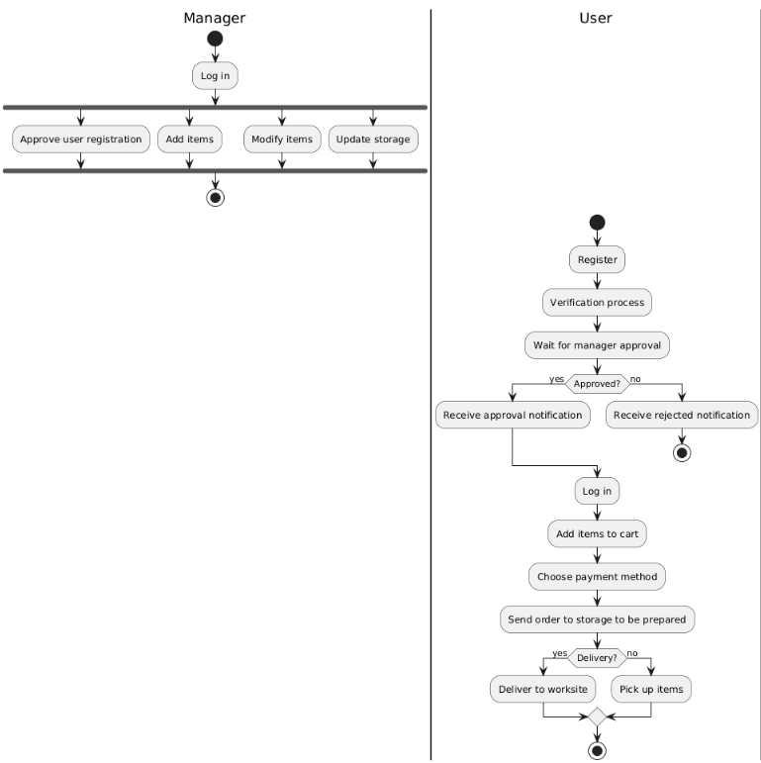

# 

*Figure 3: PowerTrack Activity Diagram*

# User Interface

Welcome to our PowerTrack application our interface offers a seamless experience for managing your orders, tracking inventory, and exploring our wide range of products.

**Login page:**

The Login Page is the entry point for users to authenticate themselves into the app.

* Enter your Username and password.
* Click on Login button to log in in for your account.
* Click on **Sign up here** URL if you don't have an account.
* Click on **Forgot Password?** URL if you don't have an account.
* Note: Failing to fill in all the fields or entering incorrect Username or password, followed by clicking "Login", will result in an error message.

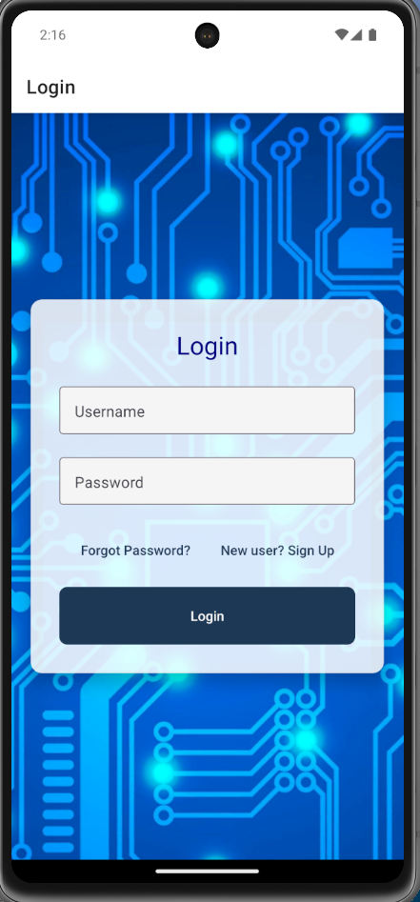

Figure 4: Login page

**Sign up Page:**

The Sign-Up page is where new users can create their account.

The page includes the following input fields:

* Name
* Family Name
* Email
* Password
* Phone Number

At the bottom of the form, there’s a Register button to create the account, and a URL option that says, "**Already have an account? Log in here**." Clicking this option redirects the user to the login page.

Figure 5: Sign up Page

**Forget Password Page:**

This page allows users to reset their password if they've forgotten it.

Here's how it works:

* 1. The user enters their email address in the provided input field.
  2. After entering the email address, the user clicks the Reset Password button.

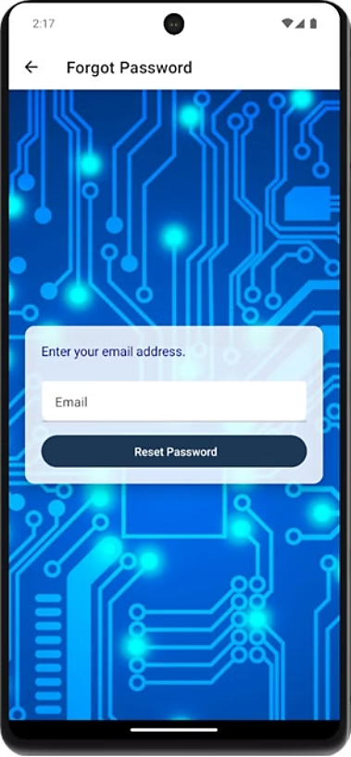

Figure 6: Forget Password Page

**Verification Page:**

This page is a security feature where users are required to enter a unique code sent to their registered phone number.

In this page there are two buttons:

1. **Resend Code Button**: If the user hasn’t received the code or it has expired, they can click the **Resend Code** button to request a new verification code.
2. **Verify Code Button**: Once the verification code is entered, users click the **Verify Code** button to confirm the code and move forward with resetting their password.

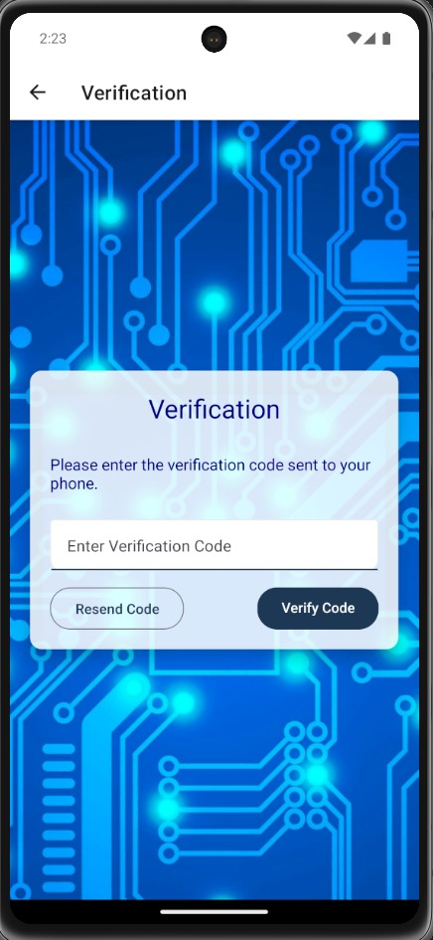

Figure 7: Verification Page

**Products Page:**

In this page we offer a variety of our products with their price across different categories for users to explore and add to their cart.

At the top of the page, users can select a specific product category to filter the results.

Figure 8: Products Page

**My Cart Page:**

This page provides an overview of the products you have selected for purchase, showing details such as:

* Product name
* Quantity
* Price per unit
* Total price for each item
* **Total Amount** which sums up the total cost of all items in your cart.
* Delete button to delete the item from your card by clicking on delete button.

At the bottom of the page there is a button labeled Proceed to Checkout. Once clicked, it takes you to the Checkout Page, where you can complete your order.

Figure 9: My Cart Page

**Sidebar on all the pages:**

* Click on Products button, and then you will go to the Products page.
* Click on the My Cart button, and then you will go to your Cart page.
* Click on the Profile button, and then you will go to your Profile page.
* Click on the About Us button, and then you will go to the About Us page.
* Click on the Contact Us button, and then you will go to the Contact Us page.

Figure 10: Sidebar

**Checkout Page:**

This page allows the user to choose how they would like to receive their order. There are two options:

* + 1. **Self-Collection:** If this option is selected, no further details are required, and the user can proceed by clicking the Next button.
    2. **Delivery**: If this option is selected, the user must enter their delivery details, including his city and the address.

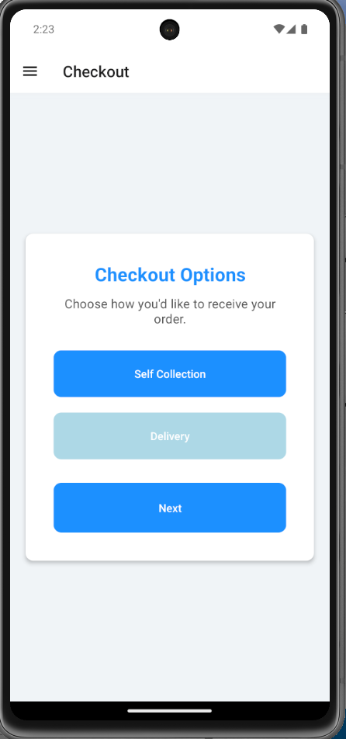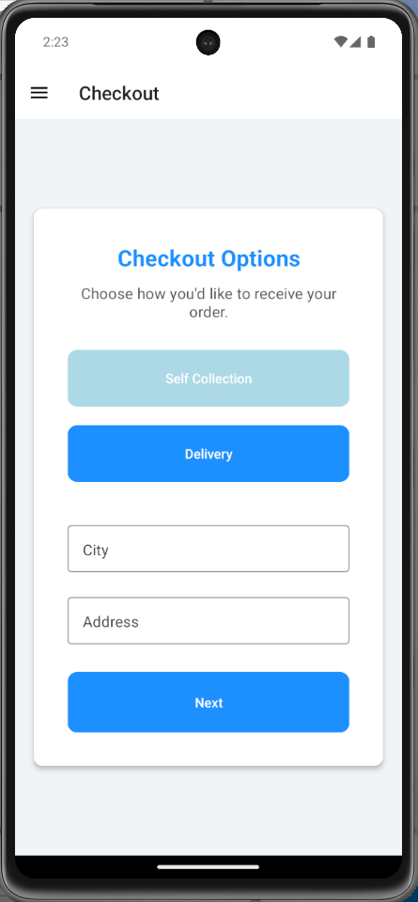

Figure 11: Checkout Page (Select Self Collection option)

Figure 12: Checkout Page (Select Delivery option)

**Payment Page:**

This page allows users to choose their preferred payment method and enter the necessary details to complete their purchase.

**Select Payment Method**: Users are prompted to choose one of the following payment options:

1. **Credit Card**: Users can enter their credit card details.
2. **Pay by Check**: Option to pay by check.
3. **Bank Transfer**: Option to pay via bank transfer.

If the user selects the Credit Card option, they are presented with fields to enter card details such as:

* Cardholder Name
* Card Number
* Expiration Date
* CVV

After entering the payment details, the user clicks the Submit Payment button to process the transaction and complete their order.

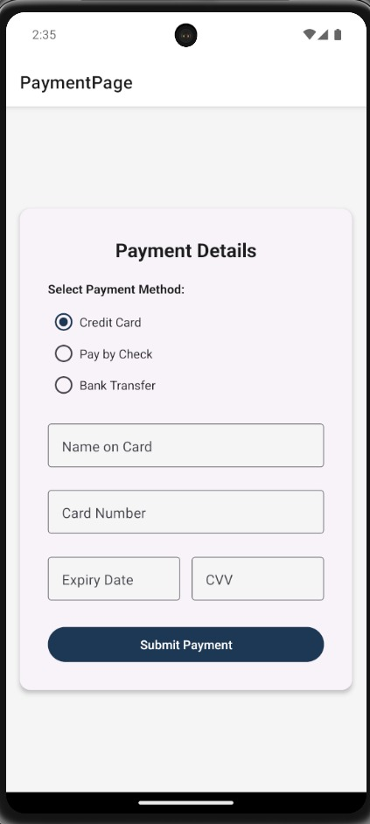

Figure 13: Payment Page

**Profile Page:**

In this page we provide the user with an overview of their personal information (name, family name, email), and the ability to edit them.

At the top of the page a profile image is displayed, representing the user photo.

The user can edit their personal details (name, family name, email) by clicking the **Edit Profile** button or the **Edit Icon** located in the top right corner of the page.

At the bottom of the page, there is a Logout button. The user can click this button to log out of their account and return to the login screen.

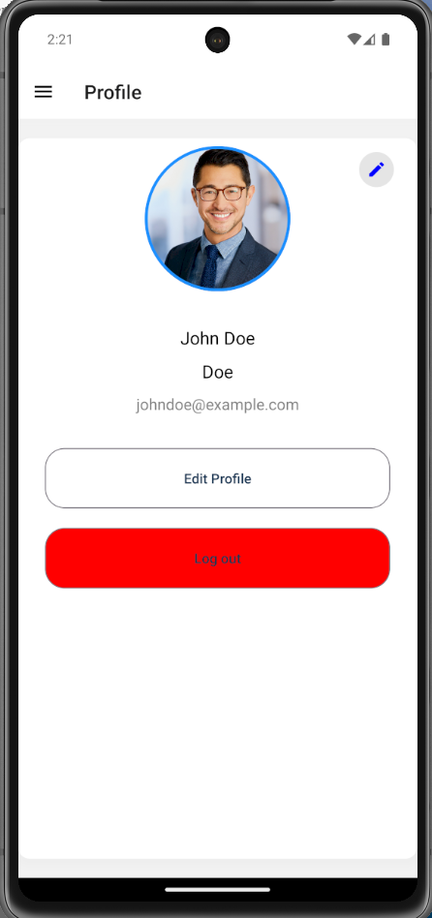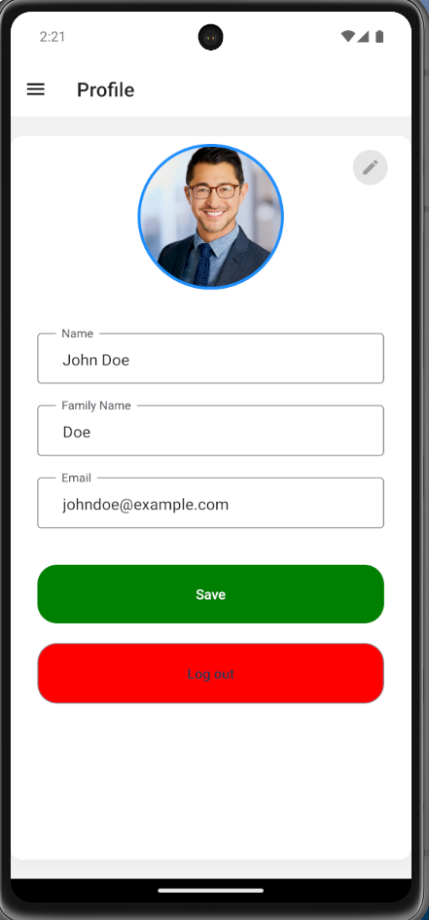

Figure 14: Profile Page

Figure 15: Profile Page (Edit details)

**Contact Us Page:**

On this page, you can reach out with any messages or questions you may have. Follow these steps to send your inquiry:

* **Name: Enter your full name.**
* **Email: Provide your email address.**
* **Message: Write your message or question.**

Click the Send Message button to submit your inquiry. A confirmation will appear once your message is sent.

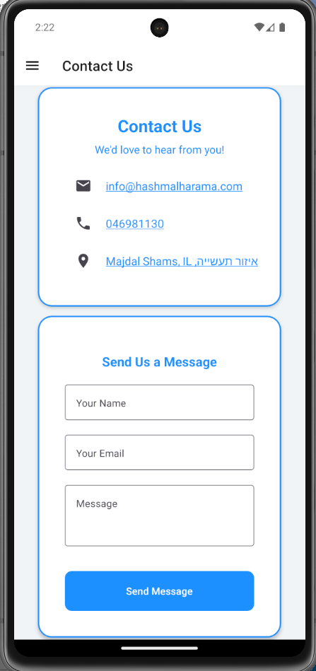

Figure 16: Contact Us Page

**About Us Page:**

This page gives users a brief introduction to the PowerTrack application and provides an overview of our key values and offerings:

* Ashort introduction of our app PowerTrack.
* Our Mission.
* What we Offer.
* Why choose us

At the bottom of the page, there's a **Contact Us** button, allowing users to reach out if they have any questions or need support.

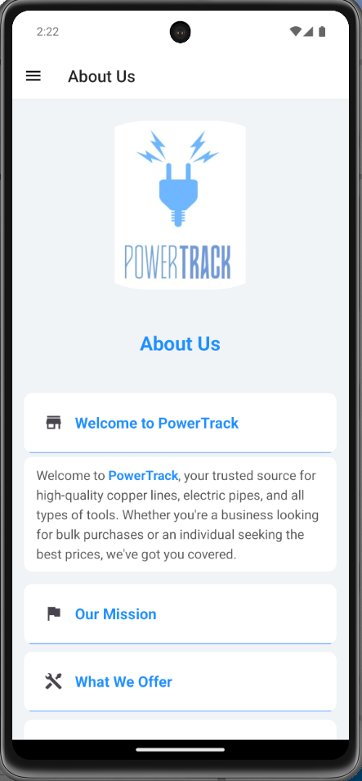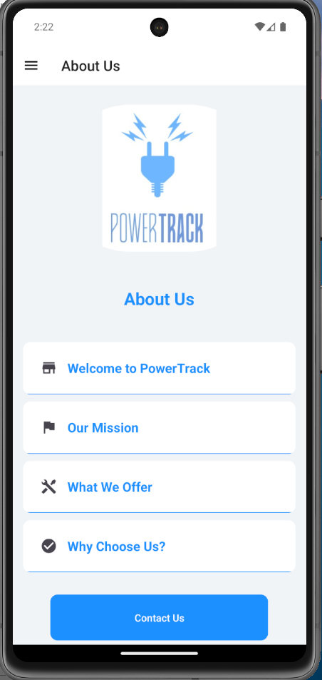

Figure 17: About Us Page

Figure 18: About Us Page (Welcome to our PowerTrack option is select)

# 7. Verification and Evaluation

We'll outline the comprehensive testing strategies and evaluation criteria used to ensure that the PowerTrack system meets its design specifications, functional requirements, and user expectations.

# 7.1 Verification

Verification involves checking that the PowerTrack system conforms to the design specifications and requirements.

**Unit Testing:**

* + Each module of the PowerTrack system will be tested individually to ensure that it functions correctly.
  + Unit tests will cover various scenarios, including edge cases, to validate the correctness of individual functions and methods.

|  |  |  |
| --- | --- | --- |
| Test Case ID | Description | Expected Result |
| TC-1 | Verify the system allows the user to enter new orders into the system. | The user can successfully enter and save new order details into the system. |
| TC-2 | Verify the system allows the user to track the status of orders. | The user can view the status of any order using the order tracking feature. |
| TC-3 | Verify the system allows the user to maintain customer details and order history. | The user can add, update, and retrieve customer details and view their order history. |
| TC-4 | Verify the system allows the user to log in to their account. | The user can log in using valid credentials and gain access to the system. |
| TC-5 | Verify the system allows the user to sign up for a new account. | New users can create an account by providing the necessary information and completing the registration process. |
| TC-6 | Verify the system allows warehouse staff to generate pick lists to prepare orders. | Warehouse staff can generate pick lists for orders to prepare them for shipment. |
| TC-7 | Verify the system allows the user to provide instructions for packing orders. | The user can add specific packing instructions to an order. |
| TC-8 | Verify the system allows the user to integrate with shipping carriers to manage shipment details and track deliveries. | The system integrates with shipping carriers, allowing users to manage shipment details and track deliveries. |
| TC-9 | Verify the system allows customers to select and manage orders for in-store pickup. | Customers can select and manage orders for in-store pickup through the system. |
| TC-10 | Verify the system allows the user to track inventory levels in real-time. | The user can view real-time inventory levels, updated dynamically. |
| TC-11 | Verify the system can generate alerts for low stock levels. | The system sends alerts when inventory levels fall below the specified threshold. |
| TC-12 | Verify the system supports regular audits to verify inventory accuracy. | The system provides features for conducting and recording inventory audits. |
| TC-13 | Verify the system implements a POS system for handling sales transactions in the store. | The system handles sales transactions, including processing payments and updating inventory. |
| TC-14 | Verify the system can maintain a catalogue of all available products, including those manufactured in-house and other electrical supplies. | The system maintains an up-to-date product catalogue that includes all products available for sale. |
| TC-15 | Verify the system provides tools for customer service representatives to manage inquiries and returns. | Customer service representatives can use the system to manage customer inquiries and process returns. |

1. **Integration Testing:** Ensure that different modules of the PowerTrack system work together seamlessly.

|  |  |  |
| --- | --- | --- |
| Test Case ID | Description | Expected Result |
| TC-INT-001 | Verify integration between order processing module and inventory management module. | Orders placed update inventory levels accurately. |
| TC-INT-002 | Verify integration between user interface and backend database. | Data entered in the UI is correctly saved and retrieved from the database. |
| TC-INT-003 | Verify integration between customer details module and order history module. | Customer details and order history are correctly linked and retrievable. |
| TC-INT-004 | Verify integration with external shipping carriers. | Shipment details and tracking information are accurately updated and retrievable. |

1. **System Testing:** Validate the complete and integrated PowerTrack system

|  |  |  |
| --- | --- | --- |
| Test Case ID | Description | Expected Result |
| TC-SYS-1 | Verify end-to-end workflow from order placement to delivery. | The entire process from placing an order to updating inventory and managing shipment works as expected. |
| TC-SYS-2 | Verify complete user registration and login process. | Users can register, log in, and access their accounts without issues. |
| TC-SYS-3 | Verify complete POS transaction process. | Sales transactions are processed accurately, and inventory is updated in real-time. |

1. **User Acceptance Testing (UAT):** Confirm that the PowerTrack system meets user requirements and expectations.

|  |  |  |
| --- | --- | --- |
| Test Case ID | Description | Expected Result |
| TC-UAT-1 | Verify warehouse staff can generate and use pick lists. | Warehouse staff can generate pick lists and use them to prepare orders for shipment. |
| TC-UAT-2 | Verify customer service representatives can manage inquiries and returns. | Customer service representatives can efficiently handle customer inquiries and process returns. |

1. **Performance Testing:** Assess the performance characteristics of the PowerTrack system under various conditions.

|  |  |  |
| --- | --- | --- |
| Test Case ID | Description | Expected Result |
| TC-PERF-1 | Verify system performance under peak load conditions. | The system remains stable and responsive under high user traffic. |
| TC-PERF-2 | Verify system scalability by adding more servers. | The system can handle increased load efficiently with additional servers. |

# 7.3 Evaluation

1. **Functional Evaluation:**
   * Assess whether the PowerTrack system fulfills all specified functional requirements.
   * Regularly review system functionalities to ensure they continue to meet the evolving needs of the business.
2. **Performance Evaluation:**
   * Monitor the system’s performance metrics, including response time, uptime, and resource utilization.
   * Use performance data to identify areas for improvement and ensure the system remains efficient.
3. **Usability Evaluation:**
   * Collect feedback from users regarding the system’s user interface and overall usability.
   * Conduct usability testing sessions to identify any issues that users may encounter and make necessary improvements.
4. **Security Evaluation:**
   * Perform regular security audits to ensure the system is protected against potential threats.
   * Evaluate the effectiveness of security measures and update them as needed to protect sensitive data.
5. **Scalability Evaluation:**
   * Assess the system’s ability to scale with the growth of the business.
   * Ensure that the PowerTrack system can handle increasing numbers of users and larger volumes of data without performance degradation.
6. **Customer Satisfaction Evaluation:**
   * Measure customer satisfaction levels through surveys and feedback forms.
   * Use customer feedback to make continuous improvements to the system, enhancing overall satisfaction and loyalty.

# 7.4 Continuous Improvement

Continuous improvement is vital to maintaining the effectiveness of the PowerTrack system. Regularly scheduled evaluations and updates will ensure that the system evolves with the business needs and technological advancements.

* **Feedback Loop:**
  + Establish a feedback loop with users to collect insights and suggestions for improvements.
  + Implement an agile approach to incorporate user feedback into regular updates and enhancements.
* **Regular Updates:**
  + Schedule regular system updates to address any identified issues and implement new features.
  + Keep the system aligned with the latest industry standards and best practices.
* **Training and Support:**
  + Provide ongoing training and support to users to maximize the system’s benefits.
  + Offer resources and assistance to help users adapt to any changes and make the most of the PowerTrack system.

# 8. References ­­­­­­

* 1. [Enterprise resource planning - Wikipedia](https://en.wikipedia.org/wiki/Enterprise_resource_planning)
  2. [Inventory Management Software Features: Tools To Look For (cleverence.com)](https://www.cleverence.com/articles/business-blogs/inventory-management-software-features-tools-to-look-for/)
  3. [11 Best Ecommerce Software for Your Business in 2024 - Shopify](https://www.shopify.com/blog/ecommerce-software)
  4. Smith, J., & Jones, M. (2020). The impact of automation on inventory management accuracy. Journal of Operations Management, 45(2), 123-135.
  5. Johnson, L., Davis, K., & Clark, R. (2019). Benefits of integrated database systems for real-time updates and reporting. International Journal of Information Systems, 38(4), 210-225.
  6. Brown, T., & Green, S. (2018). Addressing the challenges of inventory management in the electrical industry with tailored ERP solutions. Industry Technology Review, 27(3), 98-110.